1. A.

|  |
| --- |
|  |

B. 2.5*4 marks

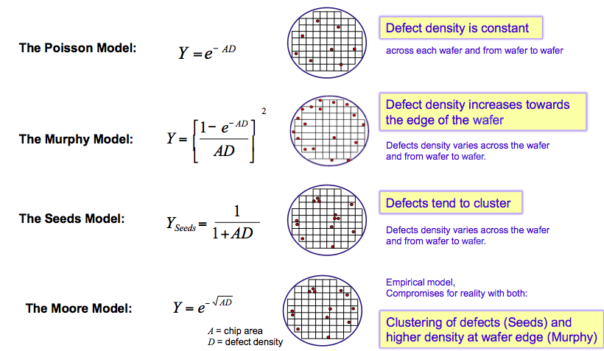

1. Given,

|  |  |  |
| --- | --- | --- |
| D=2 | Alpha = 0.75 | A = 42 mm2 = 0.42 cm­2 |
| Wafer has 100 chips | Total cost 365 dollars |  |

Answer of i

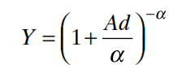🡪 Y = ( 1 + (0.42*2)/.75)^-0.75 🡪 Y = ( 2.14 )^-0.75 🡪 Y = 0.569

Total good chips = 100*0.569 = 56.9 = 56

Processing cost of 20 chips = (365*20)/56 = 128 USD or 130 USD

Answer of ii

|  |  |
| --- | --- |
| D=2 | Alpha = 0.75 |
| **Wafer has 100/1.2 chips = 83.33 = 83 chips** | **A = 42 mm2 = 0.42 cm­2 * 1.2 = 0.504 cm2** |

Total cost 365 dollars



Y = ( 1 + (0.504*2)/.75)^-0.75 🡪 Y = 0.527 = 0.53

Total good chips = 83*0.53 = 43

Processing cost of 1 chips = 365/43 = 8.48 USD

1. Given

|  |  |  |
| --- | --- | --- |
| Ef – Ev = 2 eV | Nv = 1.04 * 1019 | T = 27C = 300K |

Po = nv

Po = 1.04 * 1019

Po = 1.04 * 1019 * 2.909 * 10-34

Po = 3.02536 * 10-15

|  |  |  |
| --- | --- | --- |
| Ec – Ef = 2 eV | Nc = 2.8 * 1019 | T = 27C = 300K |

no = nc

no = 2.8 * 1019

no = 8.1452 * 10-15

B. first p-type

Second n-type

1. Given,

|  |  |  |  |  |
| --- | --- | --- | --- | --- |
| Vt = 1V | Vgs = 5V | µ = 350 | Tox = 100 A | W/L = 10 |

First calculate Beta

β = µ Cox W/L = 350 * (3.9*8.854*10^-14/100*10^-8)

β = 1208.025 * 10-6 A/V2

β = 1208 µA/V2

Now, VGT = Vgs - Vt 🡪 VGT = 5-1 = 4V

So, Vds  = 0-4V will be linear and >4V will be saturation

|  |  |  |  |
| --- | --- | --- | --- |
| Saturation🡪 Vds  = 5 | Linear Vds  = 1V | Linear Vds  = 2V | Linear Vds  = 3V |
| Ids = (β/2) (VGT)2  Ids = (1208/2) (16)  Ids = 9664 µA  Ids = 9.664 mA | Ids = β (VGT - Vds/2) Vds  Ids = 1208 *(4-0.5)*1  Ids = 4228 µA  Ids = 4.228 mA | Ids = β (VGT - Vds/2) Vds  Ids = 1208 (4-1)*2  Ids = 7248 µA  Ids =7.248 mA | Ids = β (VGT - Vds/2) Vds  Ids = 1208 (4-3/2)*3  Ids = 9060 µA  Ids = 9.060 mA |

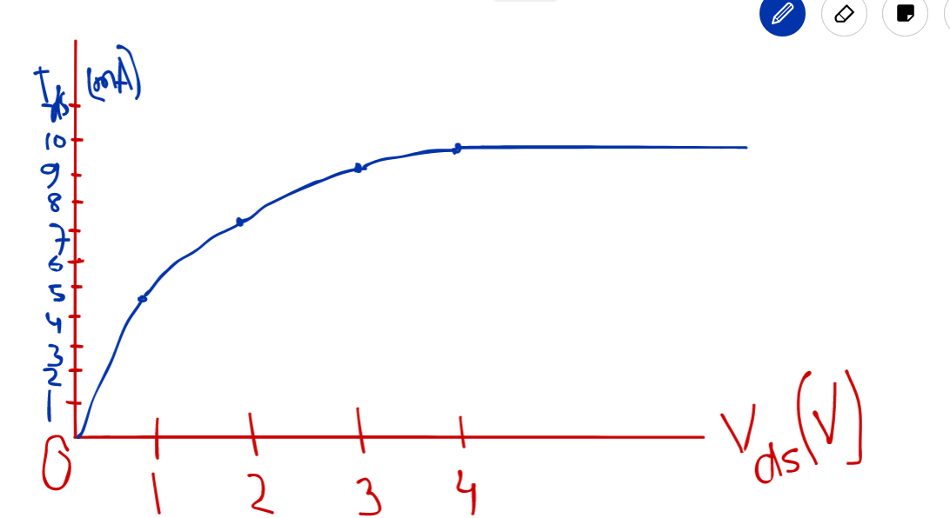

4.B

VGT gives information of saturation. 🡪 7

For example, ……. 🡪 3